
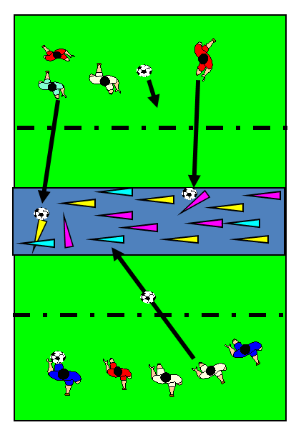
RULES – HOW TO PLAY

3 Teams x 3/4/5 aside
No. Teams1 to 3
Large rectangle with 5 zones
A/E -10 x 5m; B/D10m x 3m; C 10m x 3m
Place 10/15 cones in middle zone C for players in two outer zones A & E to aim at
Leave next 2 zones B & D as No Man’s Land
Teams Nos. 1 & 2 go to outer zones A & E with 5 balls each
Team 3 remains outside the middle zone C to count and replace the knocked down cones
Change roles after 1 min. i.e. Team 1 go to middle zone C, while Team 3 go to outer zone E etc.
Score - 1 point is scored for each cone knocked down in a set time
Winner - Team with most points after 3 goes

FOCUS
To encourage the use of the ‘HARD FOOT’ (Use top of lace) when kicking
TARGET GAME: Game 4
GAME: Cone Bombardment
A 7 E
B
C
D
E
HARDER
- Make grids D & B larger
- Less cones and balls as well as non preferred foot
- Add defenders to prevent scores in zones D & B
- Use punt kicks instead of ground kicks
- Strike a small ball with hurl

EASIER
- Allow to send with the hands i.e. roll, throw – Side of head etc.
- Make zones narrower
- Place more cones in target area
- Set balls on domes to kick when using Hard Foot for ground kicks

COACHING POINTS
HEAD – Ground Kicking
- Head up, looking for cone you hope to aim at before kicking, But......
- Keep head down until well after kicking – Count ‘1,2’ before lifting head as this encourages keeping the head down and still
HANDS
- Bring hand on kicking side out to the side to aid balance when kicking while other arm moves behind body
FEET
- Use ‘Step & Kick’ technique when kicking i.e. Step non kicking foot to the side of the ball and bring other foot through the back of the ball
- Keep ‘Toe Down Heel Up’ Foot position to get the proper foot position for power kicking
- Always follow through by straightening the leg after impact
EQUIPMENT

- Balls

- Cones

- Sticks/ Skittles
Copyright Ulster Council
2009 GAA

